Standard blower pulley to Delta shaft adapter
Bridgeport machining
- Indicate center of rotary table. Move from right to minimize table slop.
Set rotary dials at “0”. Set rotary dial to “0” for Y-axis (in and out). Lock Y-axis.
- Rotate rotary table so that “0” mark on table is on the left and “180” on the right. No need to be exact at this time.
- Mount Comp Cams degree wheel on rotary table. Use (4) tapped holes and 3/8-16 Allen bolts for hold-down. Hand tighten.
- Use .750/.1.007/1/373 round aluminum locator to locate on center of rotary table. Remove locator. Indicate center hole +/- .001. Tighten (4) Allen bolts.
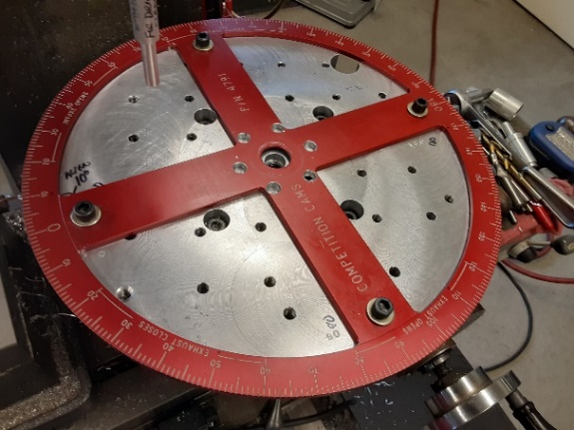
- Insert scribe in spindle and move left (table moves to right) to numbers on degree wheel.
- Rotate rotary table to align scribe with “0” on degree wheel. If pointer on vise has not been moved, it should read 10 degrees. Pointer can be set at any even number.
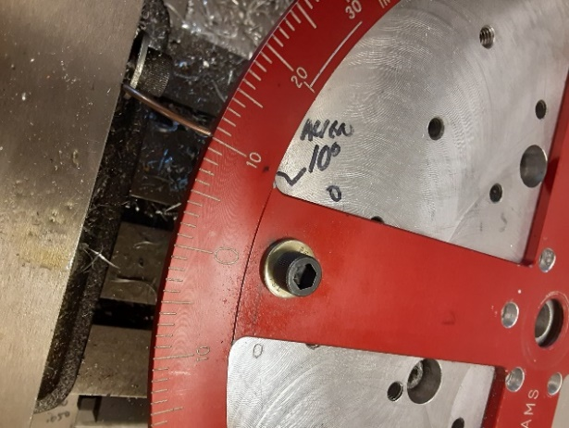
- Set-up complete.

Back Piece for Adapter
- Before mounting on table, locate on blower pulley and felt tip pen mark (6) hole locations for reference.
- Move table 1.3875 to right from center of degree wheel – should look like picture below) and lock table.
- Mount back piece (step side up) at center of rotary table using round setup locator. Rotate part to align approximately with felt tip mark.
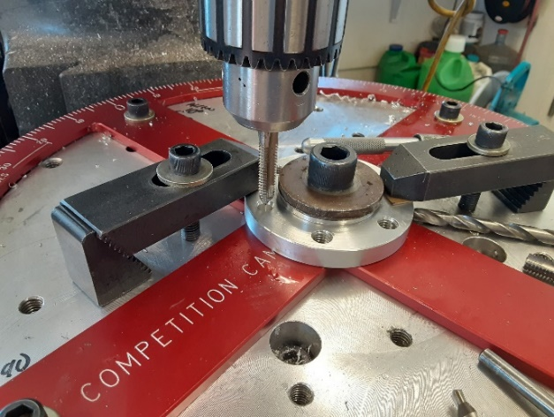
- Add (2) clamps to hold in place. Remove locator.
- Add center bolt and washer.
- Center drill, drill 5/16 for 3/8-16 tap, chamfer to .390 diameter, tap 3/8-16.
- Rotate degree wheel 60 degrees.
- Repeat drilling and tapping for (5) remaining holes at 60-degree increments. Move clamps as necessary.

Front Piece for Adapter
- Felt tip mark (6) hole locations on smooth side.
- Mount smooth side up (step down) using round setup locator.
- Clamp as above.
- Add center bolt and washer.
- Remove locator.
- Rotate rotary table to same position as started above (10 degrees?).
- Center drill, Drill 3/8 x 1” deep for pilot on c-bore tool.
- C-bore .440 deep for 3/8-16 Allen bolt and special small diameter .060 washer.
- Using 9/16 drill, lower to just touch 3/8 hole. Set quill stop .030 below.
- Chamfer hole.
- Drill through with .390 drill.
- Using a 5/8” countersink, lower to just touch .590 diameter c-bore. Set quill stop .010 below.
- Chamfer c-bore.
- Rotate degree wheel 60 degrees.
- Repeat drilling and c-bore for (5) remaining holes. Move clamps as necessary.
C-bore and 3/8-16 tapped hole for clamping bolt (front piece)
- On smooth face of “front” piece, using a felt tip marker, mark location of slitting cutter (will go from center of 1.373 hole to outside of part through tapped clamping hole). See picture below.
- Place (2) “Front” parts of equal thickness or “Front” piece on end of vise closest to Bridgeport column as shown and 1.373 spacer in opposite end of vise – step cut in “front” piece facing left as looking at Bridgeport column (step cut not visible). See picture below.
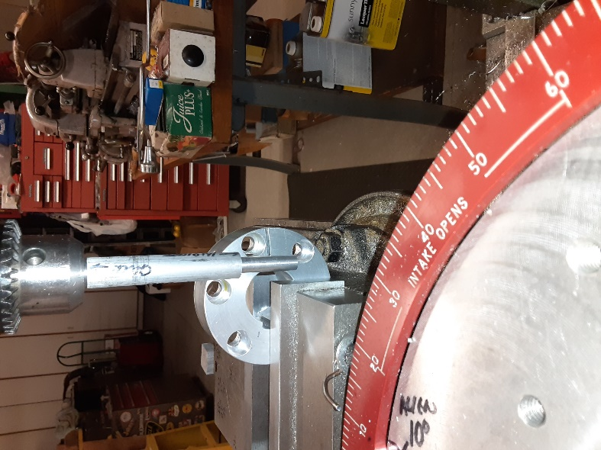
- Mount aluminum setup tool as shown – indicate round within .005.
- Drop quill and rotate part to clear (3) c-bores as well as center 1.373 hole. Should look like picture. Positioning should be as close as possible to avoid breaking through any of the holes described above – in particular center 1.373 hole. It’s very close as can be seen in picture.
- Tighten vise.
- Do not move “Y” axis. Lock axis.
- Place scribe in spindle and position at approximate center of part in “X”. Continue to position .450 from step side and mark with felt tip. Record reading on x-axis dial and note direction coming into that number.
- Using a .550-.600 diameter endmill, Spotface to ¾ cleanup.
- C-drill
- Move x-axis left to left to clear part.
- Install 3/8 drill and drop down to position of slitting cut to be made in next operation. Adjust quill stop. Note: Slitting cut is visible in picture above but very faint.
- Move x-axis back to c-drill location. Use mark on x-axis rotary dial for accuracy.
- Drill 3/8 to depth of stop
- Install c-bore tool. C-bore down to 100% cleanup. Set stop and continue down .440.
- Move x-axis to clear part. Install 5/16 drill and drop to clear bottom c-bore. Set quill stop.
- Move x-axis to c-bore location. Drill 5/16 to stop.
- Install ½” drill or countersink and lower to touch 5/16 hole. Set quill stop to obtain .410 diameter c-sink.
- Install 3/8-16 standard tap and just start tap to make perpendicular. OK to power start tap but be ready to shut off as necessary.
- Loosen chuck and raise head – tap stays in part.
- Hand tap to lower c-bore.
- Install 3/8-16 bottom tap.
- Hand tap to bottom.
- Move x-axis to clear part. Install .390 drill.
- Drop to center of slotting cut and set quill stop.
- Move x-axis back to c-bore location.
- Drill .390 to stop.
- Remove part and deburr.

Slitting Operation – front piece only
- Locate “Front” piece on slitting saw with slit layout at back using round locator which was used in previous setups. See picture below.
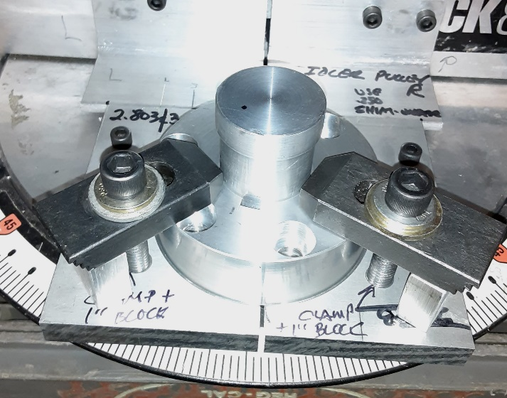
- Clamp (2) places.
- Remove setup locator.
- Slit through to 1.373 center hole opposite keyway – back side only.
- Remove part and deburr.
Keyway Operation – three steps
- Bolt Front piece (step down) and Rear piece (step up) together using round setup locator to align both pieces. Rear piece is not attached to Front piece in this picture and bolts are not shown.
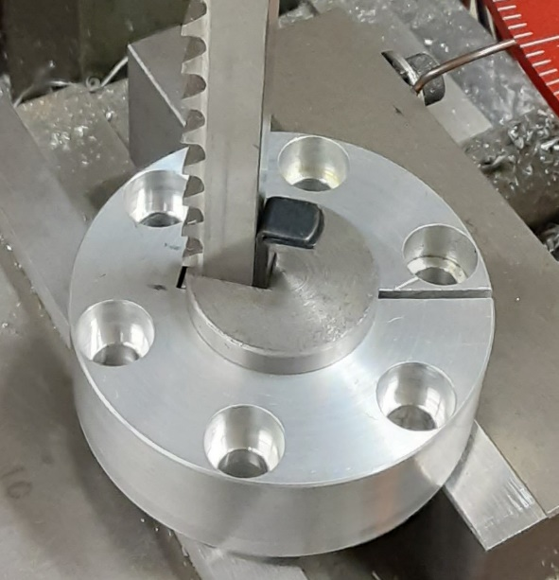
- Remove locator.
- Install 1 3/8” diameter keyway guide (shown). Use screwdriver to spread slit in part to insert guide if necessary.
- Position opposite slit cut.
- Install 5/16” keyway broach with teeth facing down.
- Broach through on vise using brass hammer to start cut and hydraulic press to finish. Note: The hydraulic press has a very short stroke. By using the vise to start, the hydraulic press operation can be completed in one operation.
- Add .050 shim (shown in picture) and broach again
- Add second .050 shim and broach for third time.
- Keyway cuts are now complete.
- Un-bolt the (2) parts.
- Deburr
- All machining operations are now complete.
Allen Bolts from Fastenal.com
- Front Piece, Blower pulley and Rear Piece attach. (6) 3/8-16 x 1 ¾”. Use small diameter .060 washers.
- Split clamp. (1) 3/8-16 x about 1 ¼”. Custom cut to maximize threads. Use small diameter .060 washer. Hand tighten bolt.
- Using calipers, measure width of slit cut. Tighten 3/8-16 and re-measure width of slit cut. Should close about .010+. If there is no movement, the bolt is too long.
3/8” x .060 hardened small diameter flat washer from McMaster.com
- These small diameter washers are used to shim a 5/8” diameter shoulder screw with 3/8 threads. Come in 100-piece pack.
5/16” Long handle and hex stock for tightening split clamp bolt
- Long handle 5/16” box wrench purchased from AutoZone or O’Reilly auto parts. Receipt in box.
- Cut 5/16” hex stock to ¾” in length and deburr.
- On vise, using small diameter socket, press hex stock through 5/16” flat washer by about ¼” or thickness of 5/16” box.

Test assembly for fit and pulley runout
- With calipers, measure distance from 2” hole in blower pulley to outside of cogs in several places for concentricity. If there is a difference by more than .003, select another pulley for this operation.
- Test fit both parts on 1.373 supercharger shaft with blower pulley sandwiched in between Front and Rear pieces. Use 5/16” key in shaft. May have to use screwdriver to spread slit in Front piece for installation.
- When in position on shaft, tighten the 3/8-16 socket head clamp bolt with long handle 5/16” box wrench and short 5/16” hex stock as supplied with adapter.
- Tighten (3) or (6) 3/8-16 socket head bolts that sandwich Front piece, blower pulley and Rear pieces together.
- Indicate outside of blower pulley for radial runout and record for customer’s instruction sheet. Indicate back face of pulley for lateral runout and record for instruction sheet.
- All pieces can ship in a USPS small flat rate box.

