Standard blower pulley to Delta shaft adapter
Aluminum bar stock requirement and Lathe Operations
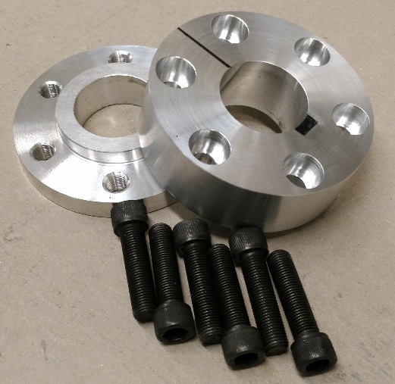
Aluminum 3 ½” Bar Stock – Order on e-bay (cut to size)
- Back piece - .437 + .150 = .587 + about 1/8 excess when cut = .71. Order 5/8”. Note: 1/8 excess required to hold on lathe. This is standard excess from supplier.
- Front piece – 1.100 + .15 = 1.250 + about 1/8 excess when cut by supplier = 1.375. Order 1 ¼”.
Back Piece
- Find square end – chuck on this end.
- Indicate OD at end furthest from chuck to minimize runout +/- .002.
- Face to cleanup.
- Turn OD to minimum cleanup down to jaw.
- Chamfer 45 degree.
- C-drill for 1.373 center hole.
- Drill 5/8” through for 1 5/16” hole.
- Drill 1 5/16” as deep as possible to clear chuck jaws. Use 1 5/16” Deming drill (shank reduced to ½”).
- Turn part around.
- Indicate OD to +/- .001.
- Face to .587 (.437 + .150).
- Cut .150 step x 2.001 +/-.001 (Check 2” hole in pulley for proper fit).
- Chamfer all sharp edges.
- Bore center hole to 1.377 +/_.001 and chamfer. Check with 1.373 locator for easy fit.

Front Piece
- Find square end – chuck on this end.
- Indicate OD at end furthest from chuck to minimize runout +/- .002.
- Face to cleanup.
- Turn OD to minimum cleanup down to jaw.
- Chamfer 45 degree.
- C-drill for 1.373 center hole.
- Drill 5/8” through for 1 5/16” hole.
- Drill 1 5/16” as deep as possible to clear chuck jaws. Use 1 5/16” Deming drill (shank reduced to ½”).
- Turn part around.
- Indicate OD to +/- .001.
- Face to 1.250 (1.100 + .150).
- Cut .150 step x 2.001 +/-.001 (Check 2” hole in pulley for proper fit).
- Chamfer all sharp edges.
- Bore center hole to 1.377 +/_.001 and chamfer. Check with 1.373 diameter aluminum locator for snug fit.

Bridgeport milling operation next.

