Delta Idler Arm – Billet
General machining instructions
For a seasoned machinist this is “old hat”, however, not everyone is “seasoned”.
This is for you! Here is what you will need to machine this part.
- Rotary Table – I purchased an 8” rotary from Vevor (or ebay) for about $220. I mounted it on my Bridgeport and indicated the center to make sure it rotated in a true circle. You first indicate the center hole within .001 and then rotate the table 360 degrees. Watch the indicator and correct any deviation. All good? I then made a trip to my local aluminum supplier and purchased a 16” x 16” x 2” piece of scrap aluminum. Drill/counterbore a minimum of (4) holes for mounting to your Bridgeport table. A round locator on back side of your 2” thick material into rotary table center hole is best. Re-indicate the center hole in the rotary table. Bolt the 16” X 16” piece of aluminum to your table as close to center as possible if locator not used and drill/bore a center hole of about 3/4" for future indicating. Drill/tap 5/8-11 for center hold-down bolt. Move the X or Y axis to the edge of the aluminum stock. Move only one axis! If you move both axes, you will end up with an egg when machined. If you decide to utilize the Y axis for a particular cut, ONLY use the Y axis from then on for that cut.
Position cutter at outside of aluminum stock and lock both axes to minimize vibration. Cut material round using rotary table. Use the ”climb cut” method for finishing – For example, if your utilizing Y axis and the cutter is near the column, the cutter will rotate clockwise and the rotary table counter-clockwise.
Climb cutting is harder on a machine with limited power like a Bridgeport as the cut starts with a heavy chip and reduces to zero as the cutter passes through the material. Check out the sketch below. Since the chip starts heavy, there is also the tendency to grab or “climb” up the material thus pulling the table into the cutter. This is prevalent in older machines with excessive backlash – you probably have one of these. The advantage of a “climb” cut is the surface finished achieved is superior. On the other hand, a “conventional” cut is easier on the machine since the cut starts at zero depth of cut and increases as the cutter moves through the material. Machine backlash has less of an effect here. The downside is that the cutter is always cutting through its own chips and therefore produces a poor finish. In conclusion, on a Bridgeport, it is best to rough cut using the “conventional” method and finish cut using the “climb” cut method. Here’s sketch showing the difference. I’ve indicated the cutter direction for clarity but actually it is the table that is moving in the opposite direction.
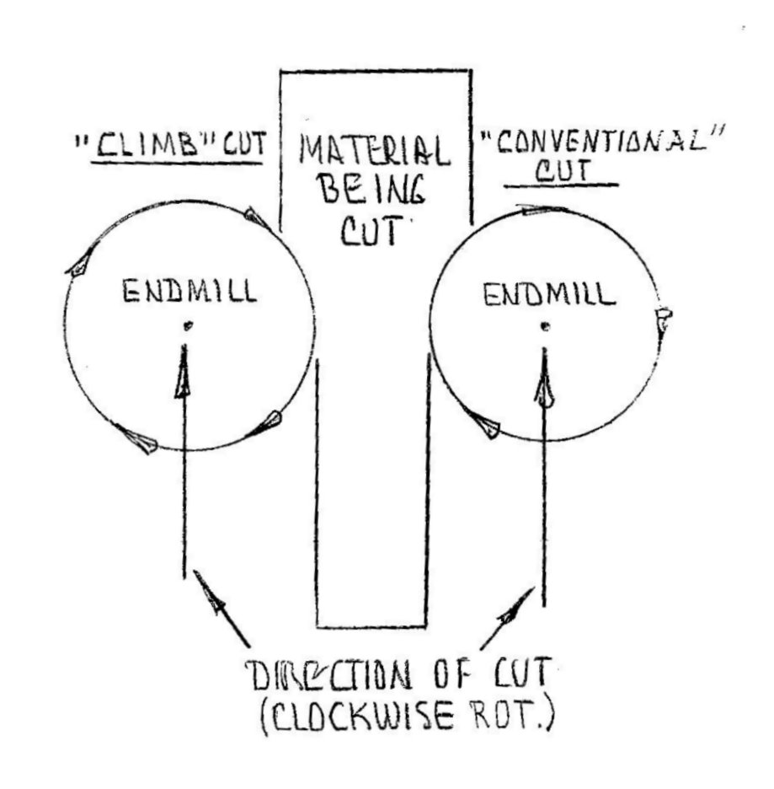
You should use a 2-flute cutter for aluminum at a speed of around 1000 rpm depending upon diameter of cutter. Higher speeds and more flutes are OK as long as there is no cutter “chatter”. Endmills over ¾” diameter are pretty hard on the machine due to limited power but you can try any size to find the limitations. Once your square “chunk” is round, make a couple of “climb” cut deflection passes to ensure a nice smooth and straight finish.
Note: ALL cutters deflect – make the extra passes. No coolant necessary. Face the top of the rotary table flat and file any ridges to provide a smooth surface. Layout a 3/8-16 tapped hole pattern for clamping. Mine are on 2” spacing.
- A cutter with 1 3/8” – 1 1/2” of flute length. The diameter should not exceed ¾” as the rotary table cannot take heavy cuts.
- A cutter with at least 1 1/4" flute x .12 corner radius for the small pockets. I utilized some reground 5/8” cutters of about .600 diameter.
- A .25 radius corner rounding cutter for over the clamp area.
- An endmill ground with 45-degree angle. Everyone should have one of these.
- A Harbor Freight or ebay boring bar and carbide bars. Tip: The cutting head is separate from the holder. Mine came loose. I tack welded the head to the holder.
- A center drill and a .390 drill for clamp area 3/8-16 x 2 ¾” through-bolt.
OK, that should do it!`
Aluminum plate stock for arm dimensions (minimum): 10.5 x 4.5 x 1 3/8.
I found some 6061 T651 which had zero warpage at finish. I learned this on the machining of Space Station parts. 144” x 144” x 6” thick T651 material. At completion of the machining process the warpage was only .025!

Part Layout
Here’s a picture of the materials needed for layout. You will be transferring the print (or in my case – sketch) dimensions onto the chunk of aluminum.
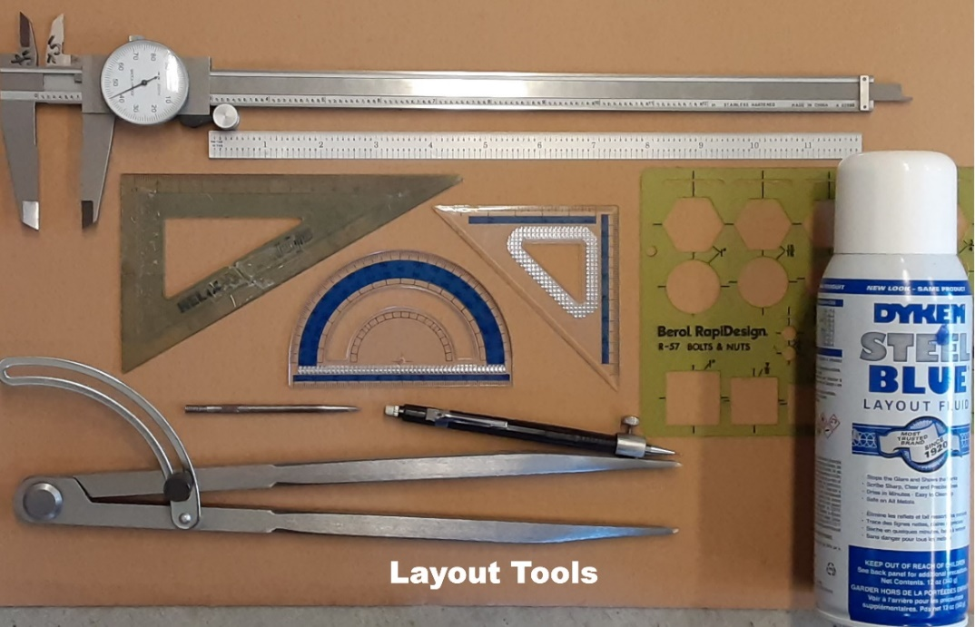
Each cut you make will be to the scribed line on the aluminum so accuracy is critical. The large compass (bottom tool) was purchased on ebay for $9.95 – very handy.
First, face off your stock in a vise to 1.340”. If you prefer, you can leave this stock thickness at 1 3/8”.
Spray with Dykem blue and scribe all lines on material per attached sketch. Should look like partial layout shown.
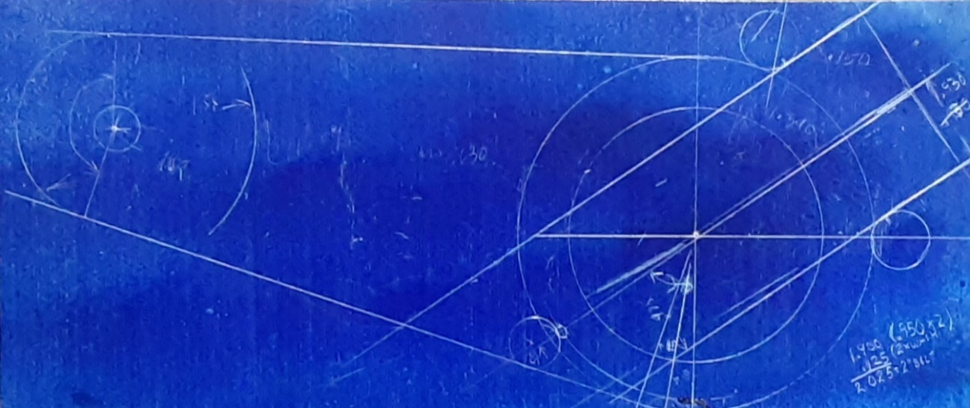

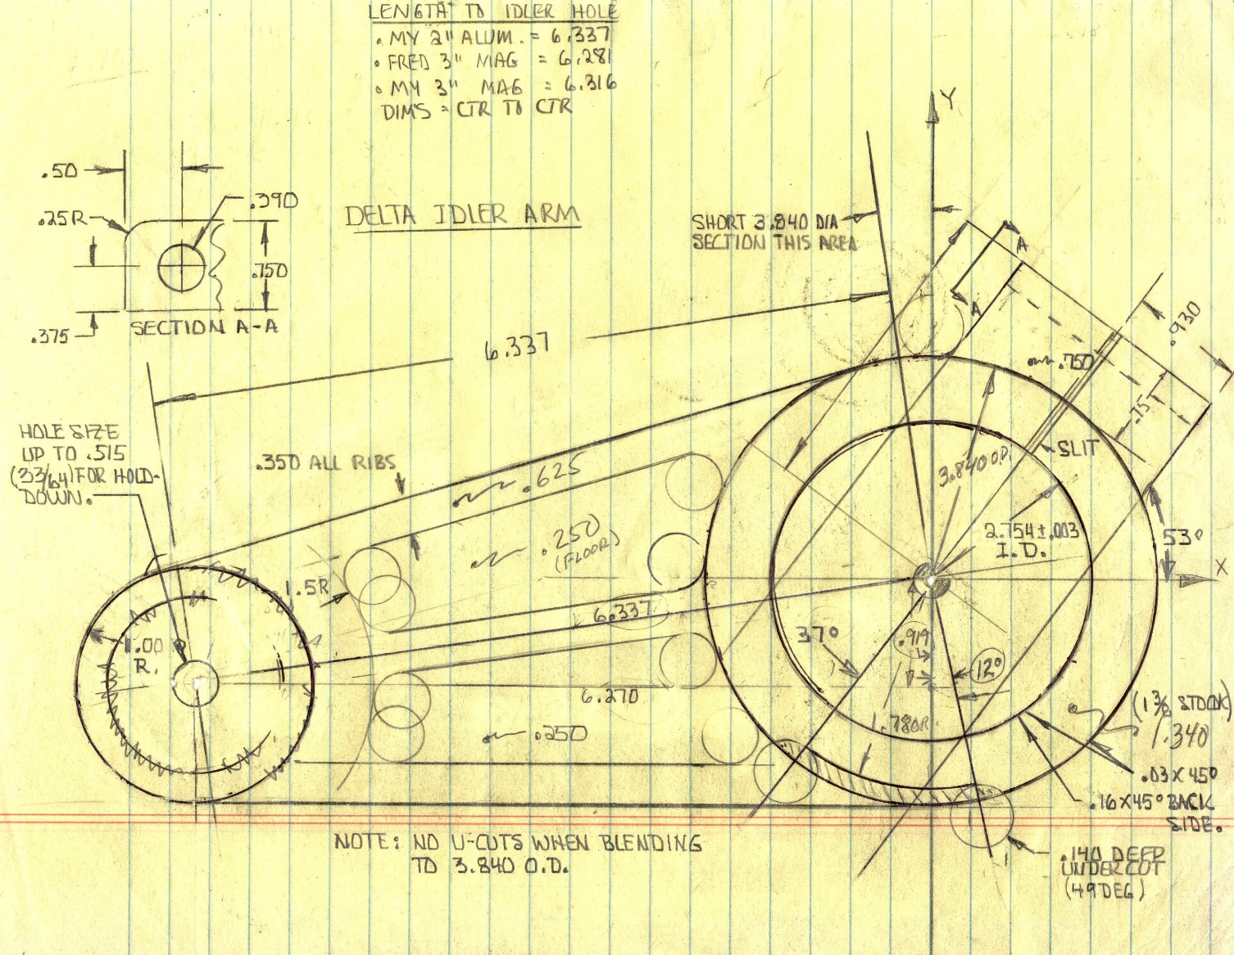

Setup for machining
Place stock in vise.
Use sturdy scribe to locate on center of large bore (right side in picture). Rotate scribe in spindle to make sure it is not running out of round.
C-drill and drill 5/8” diameter through material. Check location of 5/8” hole with indicator. If out more than .002, bore down with 5/8”+ endmill (or boring bar) to true it up. This hole will be used to center 2.750 inside diameter and 3.840 outside diameter on rotary table.
Using scribe, locate on center of 1” radius where idler pulley will mount. This is 6.337” from the center of the large bore.
Drill 5/16” hole through stock. This will get transferred to the rotary table and tapped to 3/8-16 for hold-down.
Rotary table
Mount part utilizing 5/8” bolt and washer. Position 5/16” hole in small end of material so it does not interfere with any 3/8-16 tapped holes in rotary table. Add clamps to sides.
Drill through this hole and into rotary table with 5/16” drill x about 1 ¼” deep.
Drill through aluminum stock with 3/8” drill. The edge of the drill should just break through by .02-.03.
Using stock with 3/8 hole as a guide, tap 3/8-16 in table. You can start the tap under power and then hand tap to finish depth. Keep your hand on the brake.
Deburr part and table.
Make “sacrifice plate” from .06 or .09 thick aluminum. This will be placed under the part and be the same size (10.5 x 4.5). Don’t forget the 3/8”+ and 5/8”+ holes for hold-down.
Add “sacrifice plate” beneath stock and bolt down material using 3/8” + 5/8” bolt/washer.
No need for indicating hole in center of rotary table at this time.

Machining split clamp area – straight cuts. Ref: .930 x 2 dim. + .75 dim.

Note: All straight cuts for entire part will use this method to align the cut with the X or Y table movement before machining. In this case, we will align the right edge (see .930 dimension on sketch) of the split clamp area since that scribe line is longer and thus less chance of alignment error. In the picture below, I have placed an 18” straight edge on the scribed line for edge of the split clamp area (actually slightly off the scribed line for visual clarity). You will place it on the line. Add a clamp to hold the straight edge in place. Hold-down bolts not shown. Re-check alignment of straight edge after adding clamp.
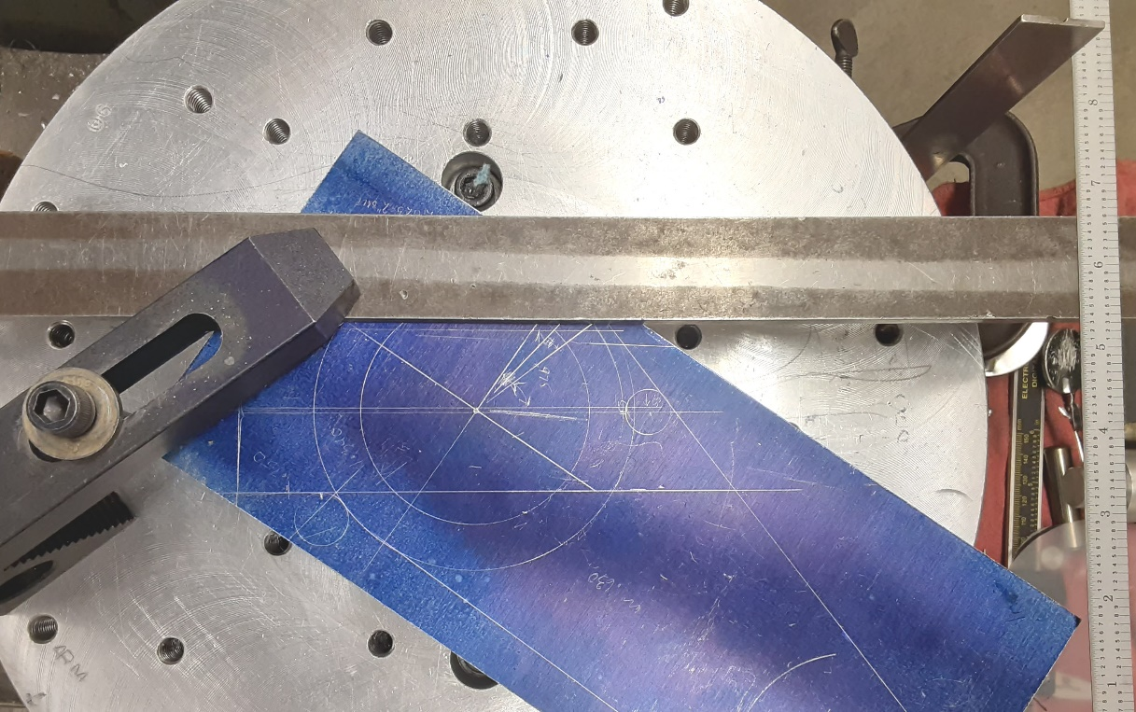

Rotate rotary table to align 18” straight edge parallel with the X axis travel. Fine- tune rotary table position by using (2) scales as shown to measure from edge of Bridgeport table closest to column to both ends of the 18” straight edge. Rotate table until both readings are the same. Try to get the readings +/- .020.
Once the readings are the same, lock the rotary table.
If the cut is long like the outer profile (bottom line on sketch), use an indictor on the 18” straight edge and move the X axis from end to end. Rotate table until the reading is within .005 from end to end.
If the cut is short like our split clamp end (ref. .930 x 2), measuring with a scale will be sufficient as we have come close when measuring both ends of the 18” straight edge. Any error along our short .930 x 2 edge will be insignificant.
With the rotary table locked, utilize an endmill of about .600 diameter with no corner radius to machine (3) sides of the split clamp area. Be very careful not to undercut the scribe line for the 3.840 diameter. Stay approximately .020 away.
Machine over top of split clamp area down to .750 thick. The remainder of this area will get finished when machining the 3.840 diameter. Note: The fillet radius where this cut meets the 3.840 diameter is .12. Don’t undercut this radius when facing to .750 – stay .140 - .150 away.
When complete, add .25 corner round to the outer edge (Sect. A-A).

Machining all areas of 3.840 diameter
Re-indicate center of rotary table or .750+ hole in center of 3.840 diameter if part has not moved. Clamp (2) places. There’s a lot of blending to 3.840 diameter here so take your time. No undercuts allowed in this area for aesthetics reasons. I’ve got a primitive (to say the least) picture here with letters shown for cutting reference. As mentioned previously, you will only be moving one axis to position for cuts (Y). A combination of Y movement and rotation is used.

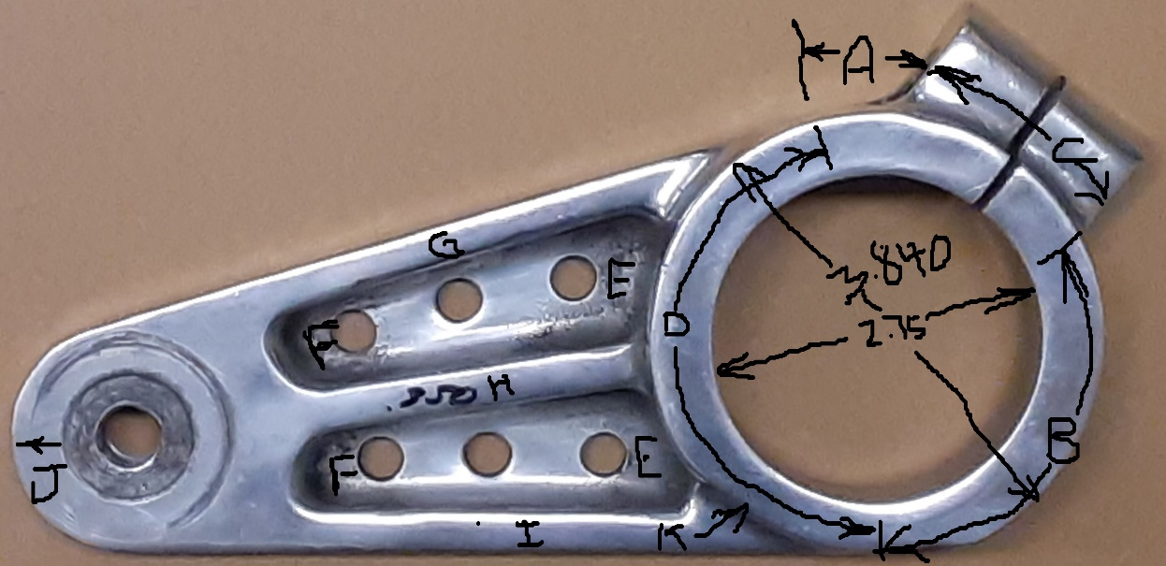
By using a cutter with no corner radius, cut the short section “A” into the sacrifice plate. Stay away from the split clamp by approximately .020. Reposition clamps as necessary.
Cut area “B” to the tangent point with “I” in the same manner.
Replace endmill with one with .12 corner radius. Finish over split clamp area “C” at .750 thick.
Cut area “D” and area “K” (.140 undercut x 49 degrees table rotation x .625 thick)
Finish 3.840 diameter in small pockets – area “E”.
Rough 2.750 inside diameter down about half way. Leave about .060 per side for finish boring from back side.
Change cutter to one with a 45-degree chamfer. Put .045 chamfer on 2.750 diameter. Since 2.750 is not finished, cut .045 outside scribed line.
Reposition part. Locate 3/8” hole in small end at center of 1.000 radius “J” on center of rotary table.
Using an endmill with a zero corner radius, machine 1.000 radius into sacrifice plate and tangent to both outer profiles at “G” and “I”.
Replace endmill with one with a .12 corner radius.
Rough and finish small radial section “F” in both pockets. Hold .250 floor dimension.
Add 18” straight edge to outside of part “G”. The straight edge will be tangent to 1.000 radius and 3.840 diameter. It is always best to machine the radial sections first and the straight section tangent to them last. If either radius is mis-located, aligning for the straight cut will still provide a nice cut. If you make the straight cut first, you’ll have a hard time blending to the radial sections.
Rotate rotary table to align with X axis as previously described.
Using an endmill with a zero corner radius, machine outside “G”.
Replace endmill with one with a .12 corner radius.
Machine inside small pocket between “G” and “H”. Hold .350 flange thickness “G” and .250 floor dimension.
Add 18” straight edge to outside of part “I”. The straight edge will be tangent to 1.000 radius and 3.840 diameter on bottom side.
Rotate rotary table to align with x axis as previously described.
Using an endmill with a zero corner radius, machine outside “I”.
Replace endmill with one with a .12 corner radius.
Machine inside small pocket between “H” and “I” and any uncut area on floor. Hold .350 flange thickness and .250 floor thickness.
Add 18” straight edge to centerline of part “H” and align with X axis.
Machine both sides of .350 flange “H” and any uncut floors in both small pockets.
Finish machine .625 thickness. Remove 3/8 bolt and clamps as necessary.
Remove part and deburr.

Turn part over. Add sacrifice plate and bolt large end. Add .715 shim beneath 3/8” bolt on small end. (1.340-.625=.715 if you have faced stock to 1.340).
If you are aware of the thread size for the idler arm bolt, it can be put in here. The Delta pulley used a 9/16-18 thread. If a modern idler pulley is used, it will probably be 5/8-18. The original Delta idler pulley diameter is about 4.8” whereas the diameter where the belt rides is about 4”.
Add (2) clamps to top of large diameter.
Machine 2.750 inside diameter to break through leaving about .06 on sides for boring operation.
Remove bolt and excess stock inside 2.750 diameter.
Using an endmill of sufficient length, machine into sacrifice plate x .06 to provide clearance for boring bar at bottom of cut.
Center rotary table on 2.750 diameter.
Add boring bar and bore to about 2.755 to fit boss on front cover. Use inside micrometer to check inside diameter top and bottom. If you have a Delta cover, you can use the 2.750 boss for checking. You do not want the bore to be smaller than the boss on the cover – a few thousandths larger is best. The boring bar is available on-line or Harbor Freight for about $50.
Using your endmill with a 45-degree angle, rotate table to machine 45-degree x .160 chamfer around 2.750+ bore.
Machining should now be complete.
Remove part and deburr.

Bolt hole for clamping
Lay a level on your vise in Y axis direction if vise jaws are pointing in the Y direction. If jaws are pointing in the X direction, the level should point in the X direction. Observe where the bubble lies.
Mount part in center of vise with small end slightly pointing up and toward column.
Lay level on short flat area near letter “A” in sketch and adjust in vise until bubble is in same location as observed when checking vise.
With scribe, locate center of flange as shown on sketch – Section A-A.
Center drill and drill .390 diameter through for 3/8 x 2.750 bolt, nut and (2) .060 washers.

Slitting operation
Slit the split clamp area as shown in the picture. For this operation I used a chop saw with a .090 wide carbide tipped blade from Harbor Freight. Clamp securely as you don’t want to ruin your “diamond” at this point.
Your part is now complete. Deburr and admire your effort.

